**For the following exercises, you have to use a Windows 7 or 10 virtual machine. To solve the exercises, create a document with screenshots including the settings for each part.**

**Exercise 1**

**First, let us create a new hard disk for the virtual machine. Then, we are going to create the**

**following partitions:**

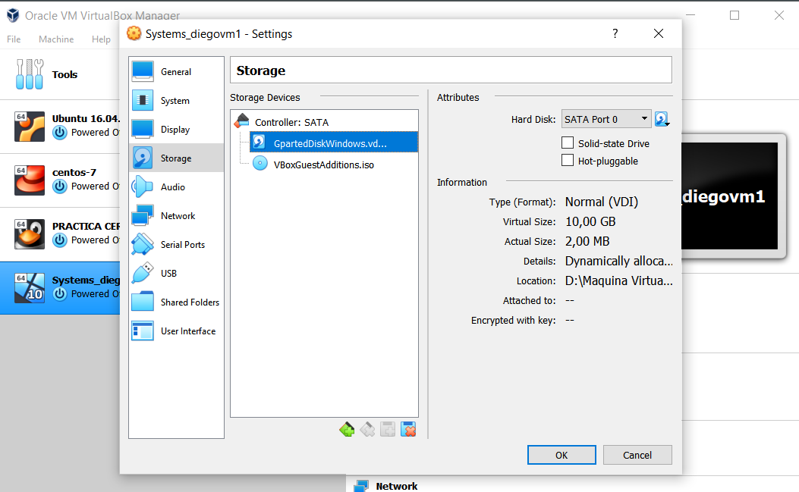

**ACCORDING TO THE RECQUIREMENTS WE HAVE CREATED A NEW DISK WITH 10GB SPACE CALLED GPARTEDDISKWINDOWS.**

**• A NTFS primary partition of 2GB called PNTFS.**

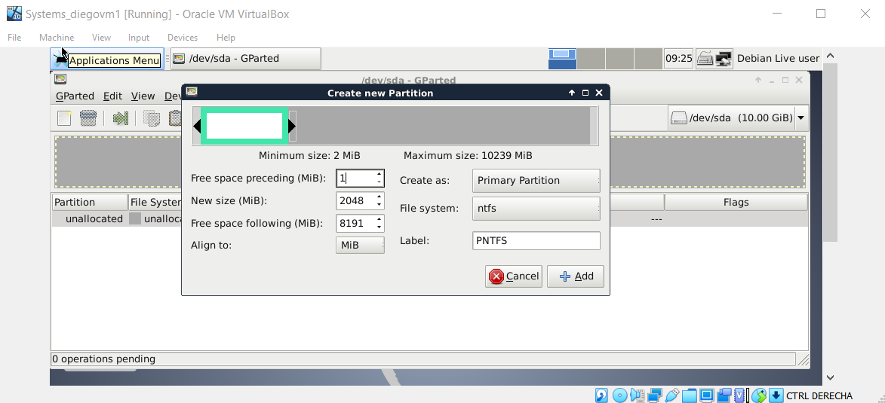

**HERE WE ARE CREATING THE PNTFS DISK WITH 2GB AS A PRIMARY PARTITION.**

**• An EXT4 primary partition of 2GB called PEXT4.**

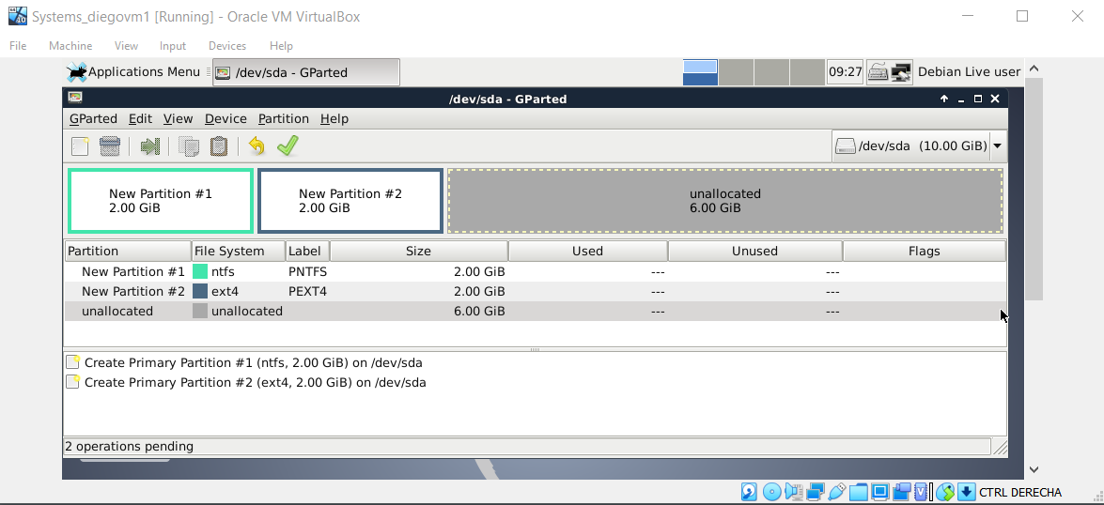

**NOW WE DO THE SAME BUT WITH A DIFFERENT FILE SYSTEM. IE. EXT4.**

**• An extended partition of 4GB.**

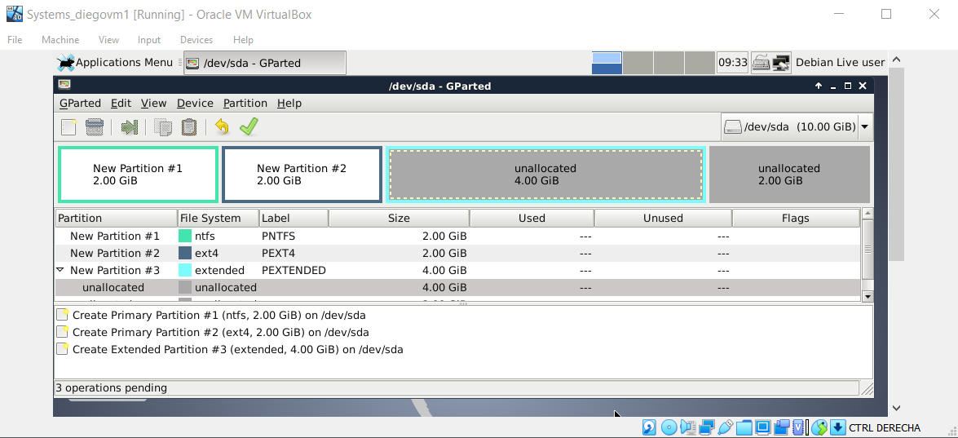

**HERE WE HAVE CREATED THE EXTENDED PARTITION WITH 4GB AS RECQUIRED AND NAMED IT PEXTENDED.**

**• A logical partition of 2GB called PFAT32.**

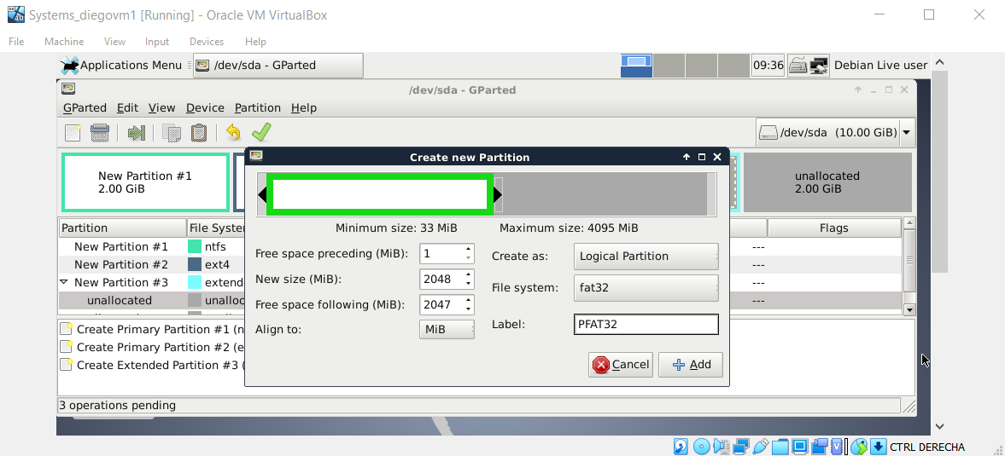

**TO CREATE A LOGICAL PARTITION, WE HAD TO DO IT INSIDE THE EXTENDED PARTITION AND AS WE CAN SEE, WE HAVE THE LOGICAL PARTITION OPTION IN THE MENU.**

**Now open Disk Management in Windows. You should have a configuration just like in the**

**picture below.**

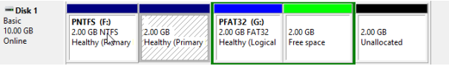

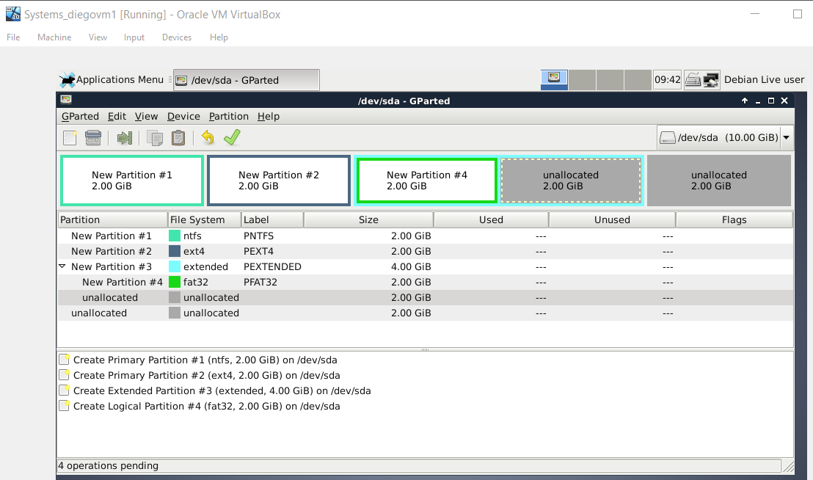

**THIS IS THE FINAL IMAGE OF HOW THE PARTITIONS ARE DISTRIBUTED.**

**Answer the following questions**

**1. Why is the file system not showed in the second partition?**

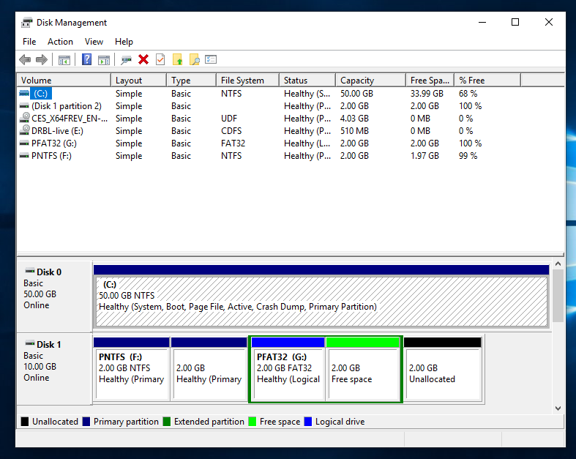

**WHEN WE LOAD WINDOWS AGAIN, WE CAN ACCESS DISK MANAGEMENT TO SEE THE PARTITIONS CREATED ON THE 10GB DISK. THE SECOND PARTITION DOESN’T SHOW THE FILE SYSTEM BECAUSE IT IS A LINUX FORMAT AND WINDOWS DOES NOT RECOGNIZE IT.**

**2. If you had to create a new partition to store 2 GB data, where would you put the partition**

**in? Which file system should you use? Justify your answer.**

**WE CAN USE EITHER THE EXTENDED PARTITION OR THE FREE SPACE THAT IS LEFT TO CREATE THE LAST 2GB OF SPACE RECQUIRED, WE CAN USE ANY FILE SYSTEM BUT KEEP IN MIND THAT WINDOWS WILL NOT RECOGNIZE EXT4 FILE SYSTEMS SO IT IS BETTER TO CREATE AN NTFS FILE SYSTEM.**

**Exercise 2**

**Create a new disk of 5GB in the same Windows virtual machine. Now, configure the partitions with GParted to get the following result:**

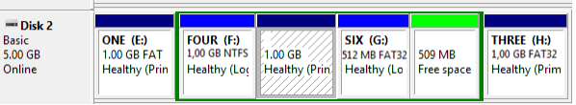

**Answer the following questions**

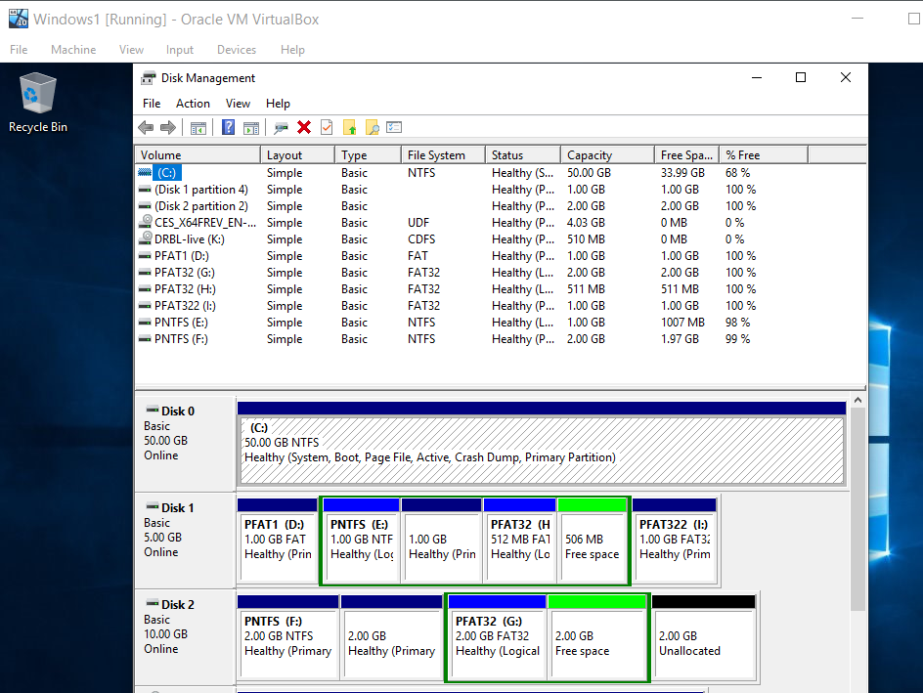

**1. How does GParted name the new hard disk?**

**INSIDE GPARTED THE DISK IS UNDER /DEV/SDB**

**2. List all the partitions you have created, indicating type and file system.**

**PFAT1 PRIMARY FAT FILE SYSTEM**

**EXTENDED 3018 MB THAT INCLUDES:**

**PNTFS LOGICAL NTFS FILE SYSTEM**

**PEXT4 LOGICAL EXT4 FILE SYSTEM**

**PFAT32 LOGICAL FAT32 FILE SYSTEM**

**506 MB FREE SPACE**

**PFAT322 PRIMARY FAT32 FILE SYSTEM**